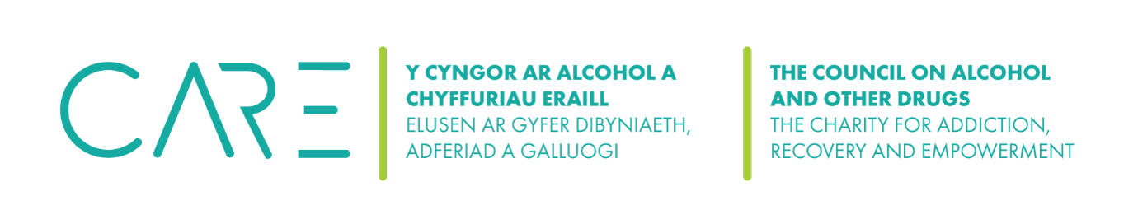
The Council on Alcohol and Other Drugs (CAOD) Cookies Policy
Cookies are small text files that are placed on your computer by websites that you visit. They are widely used in order to make websites work, or work more efficiently, as well as to provide information to the owners of the site. Cookies are used on websites to recognise a user’s device and store some information about the user’s preferences or past actions.
Cookies are used to improve services for you through, for example:
- enabling a service to recognise your device so you don't have to give the same information during one task.
- recognising that you have already given a username and password, so you do not need to enter it for every web page requested.
- measuring how many people are using services, so they can be made easier to use and that there is enough capacity to ensure they are fast.
You can manage these small files yourself and learn more about them from the Information Commissioner’s Office website: https://ico.org.uk/for-the-public/online/cookies/.
Cookies are used on this website. "Cookies" are small text files that store information about your interactions with a website, either temporarily or more permanently on the hard drive of your device. This website uses cookies to distinguish you from other users of this website, which helps us to provide you with a good experience when you browse this website and also allows us to improve this website. By continuing to browse this website, you are agreeing to our use of cookies.
We use the following cookies:
- Strictly necessary cookies. These are cookies that are required for the operation of this website. They include, for example, cookies that enable you to log into secure areas of this website.

- Analytical/performance cookies. They allow us to recognise and count the number of visitors and to see how visitors move around this website when they are using it. This helps us to improve the way this website works for example, by ensuring that users are finding what they are looking for easily.
Please note that third parties (including, for example, our partners, and providers of external services like web traffic analysis services) may also use cookies, over which we have no control. These cookies are likely to be analytical/performance cookies.
You can block cookies by activating the setting on your browser that allows you to refuse the setting of all or some cookies. However, if you use your browser settings to block all cookies (including essential cookies) you may not be able to access important functions or areas of this website.
Users may allow, block or remove cookies installed on their computer or device by changing the configuration of the used browser. Example (for Internet Explorer): Go to Tools > Internet Options > Privacy.

If you have any queries about these cookies or would like more information about them, please contact us on ………….
Last updated:

